Fight Back: Report the Spam!

We know that the Mackinac Center for Public Policy sent you an email without your permission, they may be violating the law.

You can follow these three simple steps to stop their anti-worker spam. These actions can help stop anti-worker organizations from harassing you and other union members in the future.

- Mark the email as ‘spam’ or ‘junk’ in your email inbox.

An example from a Gmail account (Other email providers may have a slightly different process). Click on the email in question and follow these prompts:
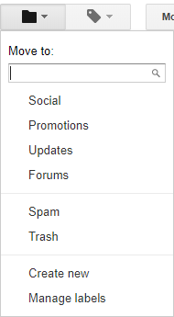

- Forward the entire email to the Federal Trade Commission at spam@uce.gov. There is no need to include a message, just forward the email in question.

- Fill out this form to notify the California Attorney General: https://oag.ca.gov/contact/consumer-complaint-against-business-or-company

Under Company name and address:
Mackinac Center for Public Policy
140 West Main Street
PO Box 568
Midland, Michigan 48460

In the comment section, copy and paste the text of the email sent by Mackinac with the following message:

I received this spam email from the Mackinac Center for Public Policy on my work email address without my permission. Please ask the Mackinac Center for Public Policy to cease all emails to my work email.

